**Setting up SVN to retrieve Startle Reflex software**

1. Download and install latest version of Tortoise SVN
   1. <http://tortoisesvn.net/downloads>
   2. You will need to restart your system
2. SVN Checkout
   1. Navigate to Matlab directory
      1. Usually something like: C:\Program Files (x86)\MATLAB\R2007b\
   2. Add a directory called ‘work’ if one does not yet exist
   3. Open the work directory
   4. Right-click and select ‘SVN Checkout’ from the context menu
   5. Enter “http://www.hebbweb.net/svn/StartleReflex” in the URL of repository field.
   6. 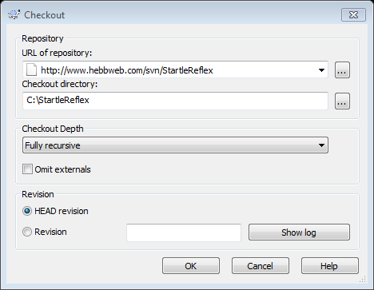
   7. Click OK and you will be prompted for a Username and Password
   8. Ask Dan for the Username and Password
   9. The program should begin downloading all of the files in the repository from the server
3. A Matlab script called “startup.m” needs to be obtained and put into the “work” directory. This file will be automatically called when Matlab launches and it will add the necessary files to the Matlab path.